Source: Transiently Powered Computer, by Benjamin Ransford et. al.

Problem: Convert the application for fitbit to an energy harvesting based system.

1. -----------Transiently Powered Computing device-------------------

- proposes software based solutions for the devices rather than better hardware, as he puts it,

"the software to complement the hardware".

Chapter one was mainly an intro on the field.

Chapter 2 – Simulating Transiently Powered Computers

Describes a simulation for CRFID using MSPSim to simulate the MSP430 chip to see how it would behave on an energy harvesting system.

\* learned that a person sitting generates about 100W of energy.

\* Energy harvesting – energy is captured and stored. – mainly micro energy harvesting

Sources: solar, wind, thermal, kinetic, salinity, radio

* The benefits are more long term, where the device requires less maintenance, and might save time and trouble.
* Advantages: mobility, installation (removal of b
* 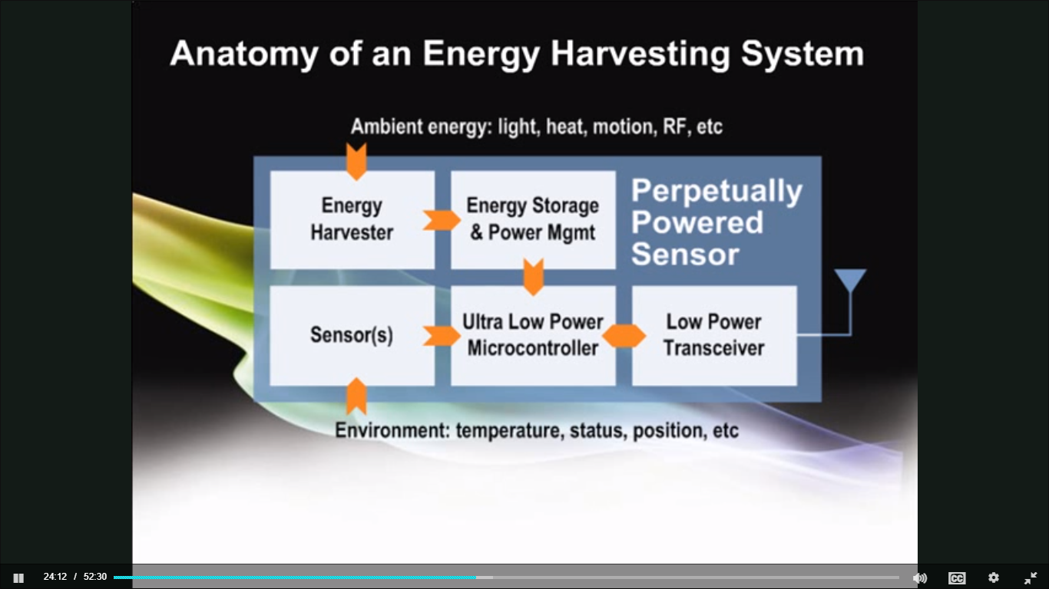
* Range of power 1.8-3.6V
* In a lot of these applications, I will need a form of energy storage, so it may as well be a battery of sorts to provide a longer-lasting energy source.
* The best place to the energy will probably be